

Aims Management Consultants is a leading business consulting firm offering top business consulting services and solutions for ISO 9001:2000, HACCP CE Marking in Delhi, NCR, Faridabad, Gurgaon, India. We provide ISO 9001:2000, HACCP, ISO 14001, ISO 27001, SA 8000, ISO 17025, TS 16949, CE marking certification Consultancy at very reasonable rates in India, Delhi. ISO India Certifications provide ISO 9001 2000 consultancy. We are specialised in all type of ISO consultancy services. We provide ISO certificates for 9001, HACCP, CE Marking, ISO 14000, ISO 22000, ISO 27001/ Information Security, Six Sigma, TS 16949, SA 8000, TQM, ISO 17025 for all types of business at cheapest rates. We are the largest best consultants in India, Delhi, Mumbai, Banglore, chennie, Hyderabad, Gurgaon. Our consultants team are highly qualified and specialised in providing iso certification consultancy.

ISO certification India India Consultants consultancy Certification India Standards iso Certification ISO Consultants Delhi ISO 9001 2000 ISO 9001 ISO 9001:2000 ISO India ISO Delhi HACCP, CE Marking iso 14001, Six Sigma, TS 16949, ISO India ISO 9001:2000 Certification Consultancy Services Aims Managment delhi india Consultants for ISO 9001:2000 iso 14000 HACCP CE Marking SA 8000 ISO 27001 iso services iso services India ISO 9001 india Consultants ISO 9001 Certificate consultants Mumbai India ISO India ISO Delhi HACCP 22001 SA 8000 ISO 14001 OHSAS ISO 27001 Consultants ISO Consultants, ISO 9000, ISO 9001, ISO 9001 2000, 9001 2000, ISO Certificate, ISO, Certificate, ISO Consultancy

Implementation Guidance for ISO 9001:2008

CONTENTS

1.0 INTRODUCTION

2.0 BACKGROUND ON ISO 9001:2008 REVISION PROCESS

3.0 USER GROUPS

4.0 IMPLEMENTATION GUIDANCE

4.1 GENERIC GUIDANCE

4.2 SPECIFIC GUIDANCE TO USER GROUPS

5.0 FREQUENTLY ASKED QUESTIONS
6.0 AUTHENTICITY OF INFORMATION REGARDING ISO 9001:2008
1. INTRODUCTION

This Implementation Guidance has been developed to assist users in understanding the issues that need to be considered during the co-existence period between ISO 9001:2000 and ISO 9001:2008.

While the changes between ISO 9001:2000 and ISO 9001:2008 are expected to have a limited impact on users, some arrangements regarding implementation are needed.

Note: To reflect the limited scope of the changes the term “implementation” is now being used to make a clear distinction with the former “transition” from ISO 9001:1994 to ISO 9001:2000, when there were significant changes throughout the standard.

A wide diffusion of this implementation guidance is recommended, in particular the comparison table between ISO 9001:2008 and ISO 9001:2000, given in Annex B to ISO 9001:2008..

ISO 9001:2008 has been developed in order to introduce clarifications to the existing requirements of ISO 9001:2000 and to improve compatibility with ISO 14001:2004. ISO 9001:2008 does not introduce additional requirements nor does it change the intent of the ISO 9001:2000 standard.

Certification to ISO 9001:2008 is not an “upgrade”, and organizations that are certified to ISO 9001:2000 should be afforded the same status as those who have already received a new certificate to ISO 9001:2008

No new requirements were introduced in this edition but, in order to benefit from the clarifications of ISO 9001:2008, users of the former version will need to take into consideration whether the clarifications introduced have an impact on their current interpretation of ISO 9001:2000, as changes may be necessary to their QMS

2. BACKGROUND TO THE ISO 9001:2008 REVISION PROCESS

In order to assist organizations to have a full understanding of the new ISO 9001:2008, it may be useful to have an insight on the revision process, how this revision reflects the inputs received from users of the standard, and the consideration given to benefits and impacts during its development.

Prior to the commencement of a revision (or amendment) to a management system standard, ISO/Guide 72:2001 Guidelines for the justification and development of management system standards recommends that a “Justification Study” is prepared to present a case for the proposed project and that it outlines details of the data and inputs used to support its arguments. In relation to the development of ISO 9001:2008 user needs were identified from the following:
- the results of a formal “Systematic Review” on ISO 9001:2000 that was performed by the members of ISO/TC 176/SC2 during 2003-2004
- feedback from the ISO/TC 176/Working Group on “Interpretations”
- the results of an extensive worldwide “User Feedback Survey on ISO 9001 and ISO 9004” by ISO/TC 176/SC 2/WG 18 and similar national surveys.

The Justification Study identified the need for an amendment, provided that the impact on users would be limited and that changes would only be introduced when there were clear benefits to users.

The key focuses of the ISO 9001:2008 amendment were to enhance the clarity of ISO 9001:2000 and to enhance its compatibility with ISO 14001:2004.

A tool for assessing the impacts versus benefits for proposed changes was created to assist the drafters of the amendment in deciding which changes should be included, and to assist in the verification of drafts against the identified user needs. The following decision making principles were applied:
1) No changes with high impact would be incorporated into the standard;
2) Changes with medium impact would only be incorporated when they provided a correspondingly medium or high benefit to users of the standard;
3) Even where a change was low impact, it had to be justified by the benefits it delivered to users, before being incorporated.

The changes incorporated in this ISO 9001:2008 edition were classified in terms of impact into the following categories:
- No changes or minimum changes on user documents, including records
- No changes or minimum changes to existing processes of the organization
- No additional training required or minimal training required
- No effects on current certifications

The benefits identified for the ISO 9001:2008 edition fall into the following categories:
- Provides clarity
- Increases compatibility with ISO 14001.
- Maintains consistency with ISO 9000 family of standards.
- Improves translatability.

3. USER GROUPS

3.1 Individual organizations using ISO 9001 (including industry associations)

a) Current Users of ISO 9001:2000
This user group is defined as having completed or being in the process of implementing ISO 9001:2000, regardless of whether they are certified or not, or whether they intend to be certified or not.

b) New Users
A New User is defined as an organisation that is either beginning to use ISO 9001:2000 or ISO 9001:2008 for the first time or is a potential user of the standard in the future.

c) Users of Industry Sector Schemes, based on ISO 9001:2000
This user group is defined as those using quality management system programmes based on ISO 9001:2000 that include additional quality management system requirements, that can either be certified or accredited under the guidance of a particular Industry Sector Scheme (e.g. ISO/TS 16949 Quality systems – Automotive suppliers – Particular requirements for the application of ISO 9001:2000).

3.2 Other user groups

These are defined as being:

a) National Standards Bodies (NSBs)
b) Accreditation Bodies (ABs)
c) Certification/Registration Bodies (CB/RBs)
d) Trainers and Consultants

4. IMPLEMENTATION GUIDANCE

4.1 Generic guidance

All users groups are strongly advised to note the Joint IAF-ISO communiqué for Implementation of accredited certification to ISO 9001:2008, which details the agreed implementation plan for accredited certification as follows:
Accredited certification to ISO 9001:2008 shall not be granted until the publication of ISO 9001:2008 as an International Standard.
Certification of conformity to ISO 9001:2008 and/or national equivalents shall only be issued after official publication of ISO 9001:2008 (which should take place before the end of 2008) and after a routine surveillance or re-certification audit against ISO 9001:2008.

Validity of certifications to ISO 9001:2000
One year after the publication of ISO 9001:2008 all accredited certifications issued (new certifications or re-certifications) shall be to ISO 9001:2008.
Twenty four months after publication by ISO of ISO 9001:2008, any existing certification issued to ISO 9001:2000 shall not be valid.

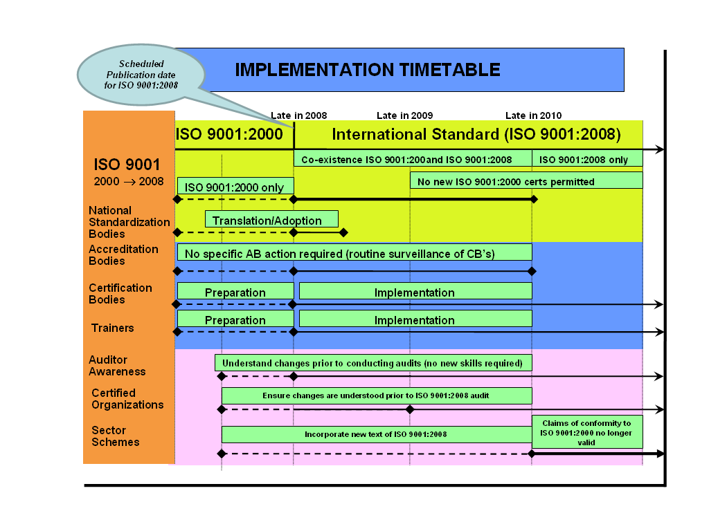
Figure 1 - Implementation timetable for ISO 9001:2008, for all user groups

Figure 1 - Implementation timetable for ISO 9001:2008, for all user groups

To benefit from the clarifications introduced into ISO 9001:2008, users (from all user groups) should note the recommendations given in the table below. Recommendations for specific user groups are given in section 4.2 further down.

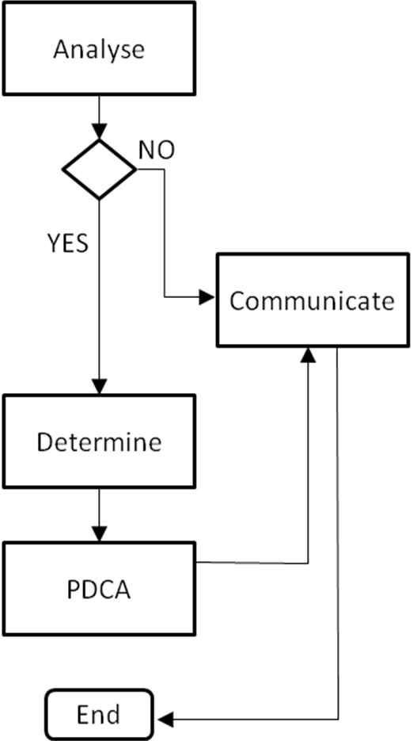 | Get acquainted with the new edition of the standard. Use Annex B in ISO 9001:2008 to facilitate identification of the clarifications
 | Was your former interpretation of ISO 9001:2000 different from the clarifications provided by ISO 9001:2008 ?
 | If not, communicate to both internal and external parties the conclusion and results of your implementation of ISO 9001:2008.
 | If yes, determine the impact of the clarifications of the new version on your current use of ISO 9001 and plan any necessary remedial actions.
Use the Plan-Do-Check-Act methodology to manage the implementation of your remedial actions, but keep in mind the timeframe provided in Figure 1.

Note that the actions may need to vary according to your user group (see 4.2 below).

4.2 Guidance for specific user groups
These recommendations complement the generic guidance to all user groups given in section 3.0 above.

4.2.1 Organizations using ISO 9001:2000

a) Current users
Organisations that are already certified to ISO 9001:2000 should contact their certification/registration bodies (CB/RB) to agree a programme for analysing the clarifications in ISO 9001:2008 in relation to their individual quality management systems and for upgrading their certificates.

Certified organizations should bear in mind that ISO 9001:2000 certificates have the same status as new ISO 9001:2008 certificates during the co-existence period.

Organizations in the process of certification to ISO 9001:2000 should change to using ISO 9001:2008 and apply for certification to it.

b) New users
New users should start by using ISO 9001:2008.

c) Industry Sector Schemes
Users of specific sector schemes are recommended to refer to the organization that is responsible that sector scheme’, e.g. for:
- ISO/TS 16 949 refer to the IATF,
- TL 9000 refer to the QuEST Forum
- AS 9000/ EN 9100 refer to the IAQG

4.2.2 National Standards Bodies

Information regarding the 2008 edition of ISO 9001 should be communicated to standard users, in a timely manner, by the national standards bodies (NSBs). It is recommended that NSB actions be synchronized with the information flows from ISO and ISO/TC 176.

NSBs are responsible, at a national level, for communicating the issues regarding the changes from ISO 9001:2000 to ISO 9001:2008 to all interested parties and for providing translations of the new edition of the standard in their national languages. It is recommended that they coordinate their communications regarding these issues with other local interested parties (for example: ABs, CB/RBs, professional quality associations, etc.).

Translation Issues - If a requirement for translation of the new standards exists, the translation process should be started as early as possible, in order to provide the equivalent national edition as soon as possible.

An NSB should analyse if there are interpretation problems in the national ISO 9001:2000 version due to former translation problems. In affirmative cases the NSB should carry out an extensive translation of the standard. If interpretation divergences still remain, the NSB is recommended to apply for clarification to the “ISO/TC 176 Interpretations Working Group” using the established “Interpretations” process.

If an NSB has no translation problem with its version of ISO 9001:2000 it can use Annex B to ISO 9001:2008 as a quick guide for preparing its translation of the standard.

4.2.4 Accreditation Bodies

ABs should refer to the joint IAF-ISO communiqué for the implementation of accredited certification to ISO 9001:2008 (see 4.1 above).

4.2.5 Certification Bodies

CBs should refer to the joint IAF-ISO communiqué for the implementation of accredited certification to ISO 9001:2008 (see 4.1 above).

CBs should remember that certificates of conformity to ISO 9001:2008 and/or its national equivalent adoptions can only be issued after the official publication of the amended standard.

It is important that accredited certification bodies ensure that their auditors are aware of the clarifications introduced in ISO 9001:2008, and their implications, prior to conducting audits to that standard.

4.2.6 Training Bodies and Consultants

All trainers and consultants should be aware of the clarifications in ISO 9001:2008. All training bodies and consultants are recommended to determine the need for updating training programs and documentation, or any other changes necessary, to the services they provide.

5.0 FREQUENTLY ASKED QUESTIONS

While this Implementation Guidance provides recommendations on a number of issues facing the different user groups during the co-existence period, it does not address more general questions about the ISO 9000 standards. Instead ISO/TC 176/SC 2 has prepared a set of frequently asked questions (FAQs) to provide such advice.

It is expected that the FAQs will be updated on a more regular basis than this Implementation Guidance. For the latest version of the FAQs, reference should be made to the open access web site at www.iso.org/tc176/sc2

6.0 AUTHENTICITY OF INFORMATION REGARDING ISO 9001:2008

The first point of contact for information regarding the requirements of ISO 9001:2008 should be your National Standards Body (for a listing of ISO’s member National Standards Bodies, see www.iso.org/iso/about/iso_members.htm).

Other recommended sources of information are:

- ISO’s web site www.iso.org provides general information regarding ISO 9001:2008 and the ISO 9004 revision programme (as well as details of its member National Standards Bodies).
- The ISO/TC176 web site www.tc176.org provides more specific information on the structure and work programme of ISO/TC176, and on the formal “interpretations” issued on ISO 9001
- The ISO/TC176/SC2 web site, www.iso.org/tc176/sc2 provides detailed information on the ISO 9001/9004 revision program, updated on a regular basis.
Aims Management Consultants is a leading business consulting firm offering top business consulting services and solutions for ISO 9001:2000, HACCP CE Marking in Delhi, NCR, Faridabad, Gurgaon, India. We provide ISO 9001:2000, HACCP, ISO 14001, ISO 27001, SA 8000, ISO 17025, TS 16949, CE marking certification Consultancy at very reasonable rates in India, Delhi. ISO India Certifications provide ISO 9001 2000 consultancy. We are specialised in all type of ISO consultancy services. We provide ISO certificates for 9001, HACCP, CE Marking, ISO 14000, ISO 22000, ISO 27001/ Information Security, Six Sigma, TS 16949, SA 8000, TQM, ISO 17025 for all types of business at cheapest rates. We are the largest best consultants in India, Delhi, Mumbai, Banglore, chennie, Hyderabad, Gurgaon. Our consultants team are highly qualified and specialised in providing iso certification consultancy.

ISO certification India India Consultants consultancy Certification India Standards iso Certification ISO Consultants Delhi ISO 9001 2000 ISO 9001 ISO 9001:2000 ISO India ISO Delhi HACCP, CE Marking iso 14001, Six Sigma, TS 16949, ISO India ISO 9001:2000 Certification Consultancy Services Aims Managment delhi india Consultants for ISO 9001:2000 iso 14000 HACCP CE Marking SA 8000 ISO 27001 iso services iso services India ISO 9001 india Consultants ISO 9001 Certificate consultants Mumbai India ISO India ISO Delhi HACCP 22001 SA 8000 ISO 14001 OHSAS ISO 27001 Consultants ISO Consultants, ISO 9000, ISO 9001, ISO 9001 2000, 9001 2000, ISO Certificate, ISO, Certificate, ISO Consultancy

